BMCMAC Program Committee Use Only

Session No:

Assigned to:
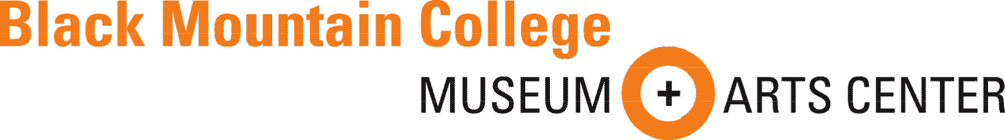

ReVIEWING Black Mountain College 9
September 29-October 1, 2017

In partnership with University of North Carolina Asheville

Conference Paper, Session, Performance or Workshop Proposal Submission
Deadline is July 9, 2017

Format (Choose one)
Below, please fill out the application section only for the format you select here.

☐ Single Presentation (20 minutes. We will find other presenters whose topics relate and form a session.)

☐ Session Panel (75 minutes with a minimum of 3 speakers)

☐ Workshop (1-2 hours)

☐ Performance

SINGLE PRESENTATION PROPOSAL

- (SINGLE PRESENTATION) Title-

- Description of Paper– (maximum of 300 words)

- Presenter contact information

Name:
Title:
Institution, Relevant Affiliations, if any:
Telephone number:
Email address:

D. Short Biography of the Presenter (maximum 200 words)

If your paper is selected, we will find an appropriate session for your paper.
Are you willing to serve as a Moderator within your session? ☐ Yes ☐ No

SESSION PANEL PROPOSAL
•A session proposer can be either a moderator and/or a speaker.
•If you are missing a speaker please indicate that you need assistance in finding a speaker for your session.

- (SESSION) Title-

- Description of Session– (maximum of 300 words)

- Session Proposer
Name:
Title:
Institution, Relevant Affiliations, if any:
Telephone number:
Email address:
- Presenters contact information

Presenter 1: Name:
Title:
Institution, Relevant Affiliations, if any:
Telephone number:
Email address:
Please include a brief bio of the speaker (200 words):

Please include a brief description of the paper (200 words):

Has the speaker been contacted? ☐ Yes ☐ No

If yes, has the speaker been confirmed? ☐ Yes ☐ No

Presenter 2: Name:
Title:
Institution, Relevant Affiliations, if any:
Telephone number:
Email address:
Please include a brief bio of the speaker (200 words):

Please include a brief description of the paper (200 words):

Has the speaker been contacted? ☐ Yes ☐ No

If yes, has the speaker been confirmed? ☐ Yes ☐ No

Presenter 3: Name:
Title:
Institution, Relevant Affiliations, if any:
Telephone number:
Email address:

Please include a brief bio of the speaker (200 words):

Please include a brief description of the paper (200 words):

Has the speaker been contacted? ☐ Yes ☐ No

If yes, has the speaker been confirmed? ☐ Yes ☐ No

Moderator contact information

The Session Proposer is also willing to serve as the Moderator ☐ Yes ☐ No

- Important: BMCM+AC will provide a projector/screen for PowerPoint presentations. However, BMCM+AC does not provide laptops for the presentations. Either the moderator or speaker will need to provide their own laptop and supply connectors. Please make sure your moderator and speakers are informed.
- Additional Program Details: You will be notified by July 15, 2016 if your session has received a final approval by the Program Committee. You will be responsible for notifying your speakers of the final approval.
- If you have any suggestions, please provide them for:
(a) Other Topics or Sessions

(b) Other Speakers

- WORKSHOP or PERFORMANCE PROPOSAL
The space for workshops is a room with tables. There is no equipment provided.

- (WORKSHOP or PERFORMANCE) Title-

- Description– (maximum of 300 words)

- Session Proposer
Name:
Title:
Institution, Relevant Affiliations, if any:
Telephone number:
Email address:
Please include a brief bio of the workshop facilitator or performer (200 words):

Please include a brief description of the workshop or performance (300 words):

Please email this document in a WORD format to alice@blackmountaincollege.org and bbutler@unca.edu
by JULY 9, 2017.

Thank you for your submission and supporting BMCM+AC!
We look forward to seeing you in Asheville, NC, in 2017!

